NORTH BOLIVAR CONSOLIDATED SCHOOL DISTRICT
204 North Edwards Avenue
Mound Bayou, MS 38762

Regular Meeting Minutes
NBCSD Library
November 16, 2020 | 6:00 pm

Board Members Present Board Member(s) Absent
Jefferick Butler, Chairman None
Tyrone Miller, Vice-Chairman
William Lucas, Member
LaShonda Walker
Jacquelyn Allen, Secretary

OTHER INDIVIDUALS PRESENT
Kenyatta McClain Ronda Rimmer Maurice Smith
Marcellus Chatman

- CALL TO ORDER/INVOCATION
At 6:01 p.m., the regular board meeting of the North Bolivar Consolidated School District convened on November 16, 2020 in the Library at North Bolivar Consolidated School District, 204 North Edwards Avenue, Mound Bayou, Mississippi 38762. Board Chairman Jefferick Butler called the meeting to order, and Tyrone Miller offered invocation.

- ADOPTION OF THE AGENDA
The Board voted to adopt the agenda as presented. Mrs. Jacquelyn Allen motioned and Mr. Tyrone Miller seconded. Mrs. LaShonda Walker, Mr. William Lucas, Mrs. Jacquelyn Allen, Mr. Tyrone Miller, and Chairman Jefferick Butler all voted aye. No one cast against the motion. PASSED

- APPROVAL OF THE MINUTES FROM October 19, 2020 Regular Board Meeting and October 29, 2020 Called Board Meeting
The Board voted to approve the minutes from the October 19, 2020 Regular Board Meeting and the October 29, 2020 Called Board Meeting. Mrs. Jacquelyn Allen motioned and Mr. Tyrone Miller seconded. Mrs. Jacquelyn Allen, Mr. Tyrone Miller, Mrs. LaShonda Walker, Mr. William Lucas, and Chairman Jefferick Butler all voted aye. Cast against the motion: none. PASSED

- SUPERINTENDENT’S REPORT
  - Board Training with John Hook on Anti-Discrimination Laws
  - November 23, 2020, 10:00 am Called Board Meeting to pay for electronic devices
  - Electronic devices (Some Have Been Received)
  - Accountability Standards Report #9
The Board voted to receive the superintendent’s report as presented. Mr. Tyrone Miller motioned and Mrs. Jacquelyn Allen seconded. Mrs. LaShonda Walker, Mr. Tyrone Miller, Mrs. Jacquelyn Allen, and Chairman Jefferick Butler all voted aye. Mr. William Lucas cast against the motion. PASSED

- CELEBRATION AND ACKNOWLEDGEMENT
  - ITM TSA CompTIA Chapter Fund Approval
  - Northside High Student, Anthony Bell, Jr.
- PRINCIPAL’S REPORT
Doris Hall, Brooks Elementary School
Addie Miller, IT Montgomery Elementary School
Fredrick Ford, Northside High School
- DISCUSSION/ACTION
  - Approval of the superintendent's recommendation to continue virtual classes and review decision during the week of December 14-18.
  - Approval of the superintendent's recommendation to participate in winter sports
  - Approval of the superintendent's recommendation to partner with Save the Children to offer a Journey of Hope psychosocial support program in North Bolivar Consolidated School District
  - Approval of the superintendent's recommendation to partner with Save the Children to offer a KinderBoost program in North Bolivar Consolidated School District
  - Approval of superintendent’s recommendation to declare the property located at 201 Green Street, Mound Bayou, Mississippi 38762 and 700 Lauderdale Street, Shelby, Mississippi 38774 not used for school purposes and is not needed in the operation of the schools of the district and to dispose of said property in accordance with Mississippi Code 37-7-455

It was motioned by Mrs. Jacquelyn Allen and seconded by Mr. Tyrone Miller to approve items 7.1 through 7.4 under the Discussion/Action. The board will revisit item 7.5. Mr. Tyrone Miller, Mrs. Jacquelyn Allen, and Chairman Jefferick Butler all voted aye. Mr. William Lucas and Mrs. LaShonda Walker voted against the motion. PASSED

- CONSENT AGENDA
  - Approval of the superintendent's recommendation to accept the following in-kind donations from Save the Children: Books $31,888.19, Home Depot Crane Kits $5,976.00, Safeguard Liquid Hand Soap $1,915.20
  - Approval of the superintendent’s recommendation to approve the following: 2020-2021 NBCSD Crisis Management Plan, 2020-2021 Brooks Elementary Crisis Management Plan, 2020-2021 ITM Crisis Management Plan, and 2020-2021 Northside High Crisis Management Plan
  - Approval of the superintendent’s recommendation to approve the following policy updates for 2020-2021: BHA, EDC, FFF, GAG, IJBD, ABB, ACC, AF, BBBCB, BBJ, BCAF, BCBK, BF, CA, CEJ, CI, DFK, DJEIB, DJEJA, EBGA, EFB, EM, EP, FB, GAA, GAAB, GAH, GBD, GBEN, GBQ, GBR, GBR-P, GBRIA, GCRAA, IAAA, IAAB, ICI, IDAG, IDCA, IDDFAA, IHAA, IIAAA, IJ-R, IK, JB, JB-P, JBA, JBC, JBD, JBDE, JCAA, JCBD, JCD, JCDAD, JDE, JGAA, JNB, JRAB, JRAC, JRAF, KL-R, LC, MB
  - Approval of the superintendent’s recommendation to approve the Scope of Engagement with Young Law Group, PLLC to serve as bond or loan counsel to the North Bolivar Consolidated School District issuance of the District’s shortfall note.
  - Approval of the superintendent’s recommendation to approve the final loan resolution for the District’s shortfall note
  - Approval of the superintendent’s recommendation to approve the following salary schedules:
    - Teacher’s Salary Schedule, Teacher Assistants Salary Schedule, Food Service Manager Salary Schedule, Food Service Cook Salary Schedule, Secretary Salary Schedule (Four Year Degree and Two Year Degree), Custodian Salary Schedule, Facilitator Salary Schedule, Coaching Supplement, and Administrator’s Salary Schedule
It was motioned by Mr. Tyrone Miller and seconded by Mrs. Jacquelyn Allen to approve all items under the Consent Agenda. Mr. Jefferick Butler, Mr. Tyrone Miller, Mrs. Jacquelyn Allen, and Mrs. Lashonda Walker all voted aye. Mr. William Lucas voted against the motion.

- PERSONNEL
  - Approval of the superintendent's recommendation to employ Tiffany Briggs as Middle School Girls Basketball Coach for the 2020-2021 school year
It was motioned by Mrs. Jacquelyn Allen and seconded by Mr. Tyrone Miller to approve the item under Personnel. Mr. William Lucas, Mr. Tyrone Miller, Mrs. Jacquelyn Allen, Mrs. LaShonda Walker and Chairman Jefferick Butler all voted aye. Cast against the motion: none. PASSED

- FINANCIAL REPORTS
  - Claim Docket

  - Activity Reports

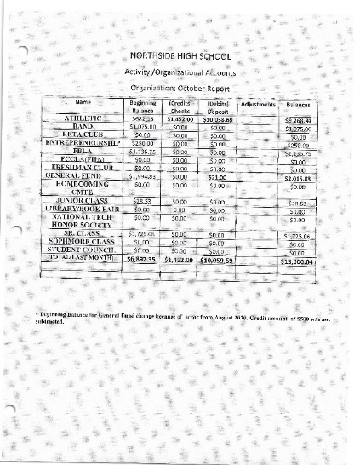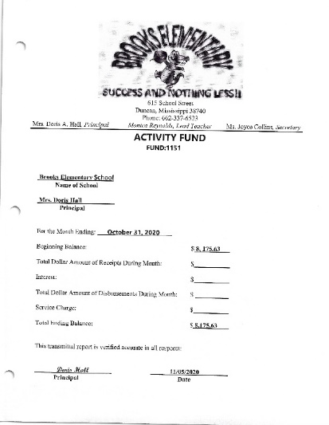
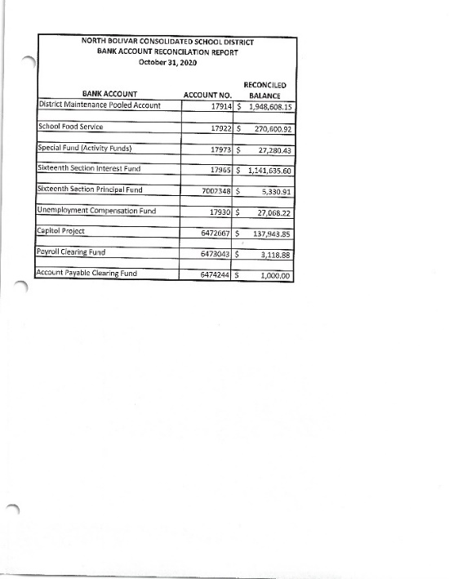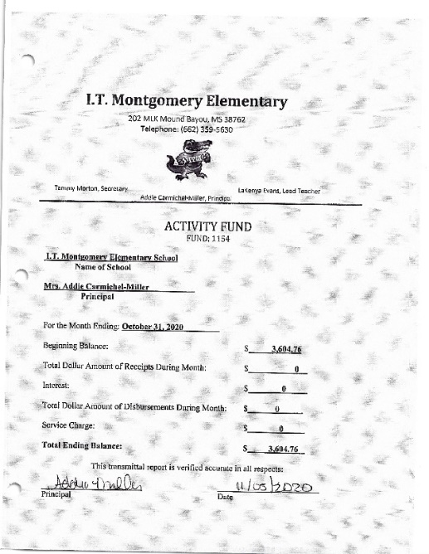
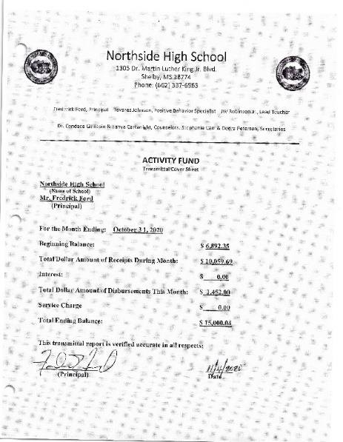

  - Financial Reports
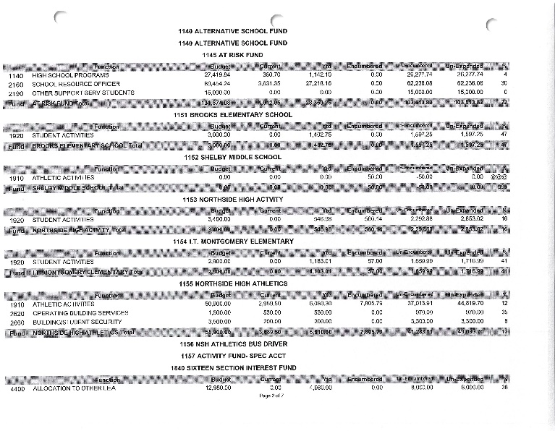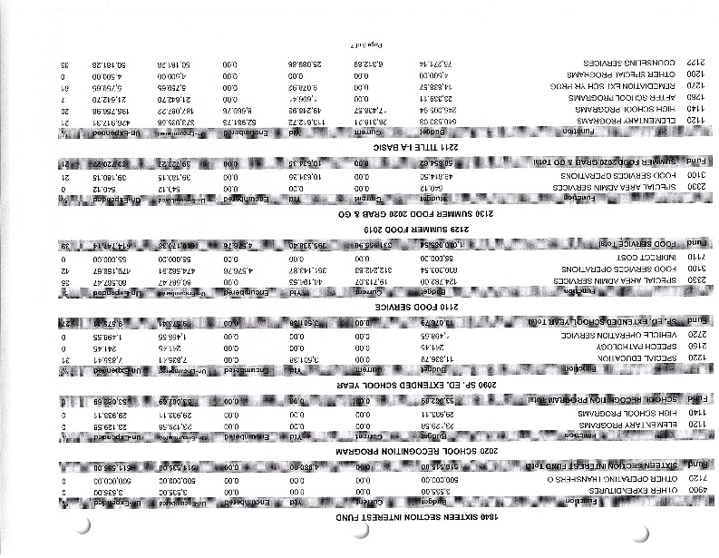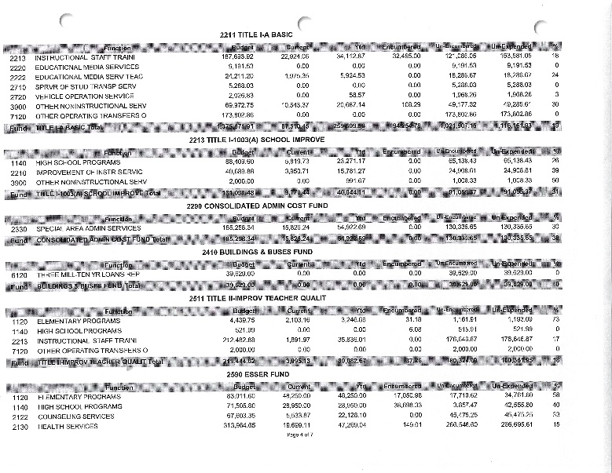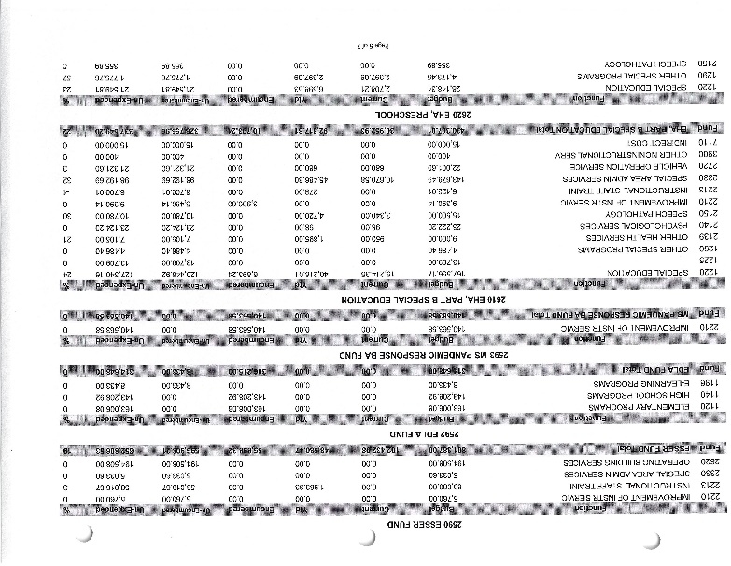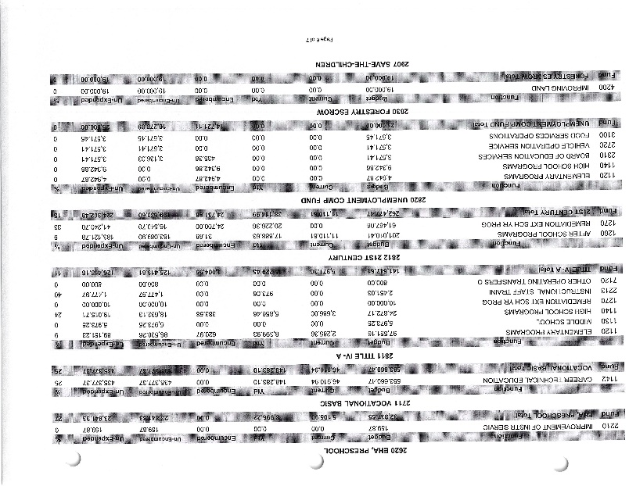
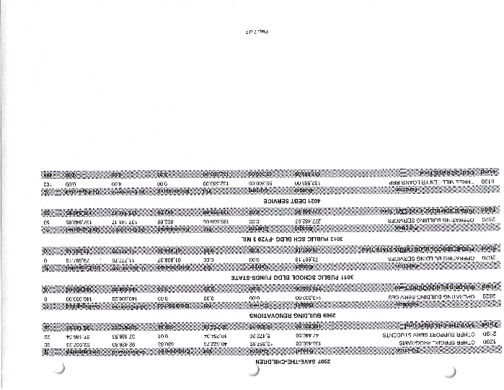
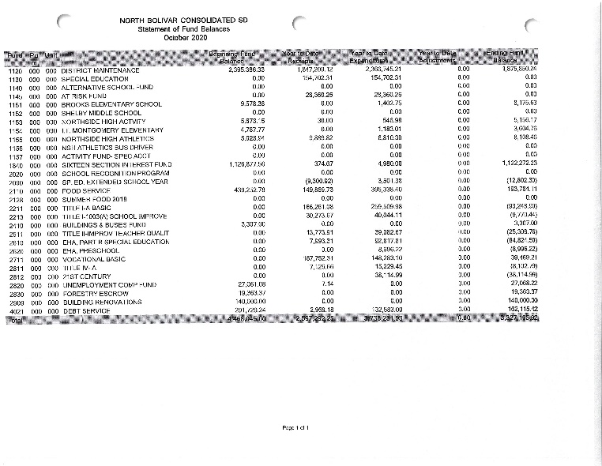
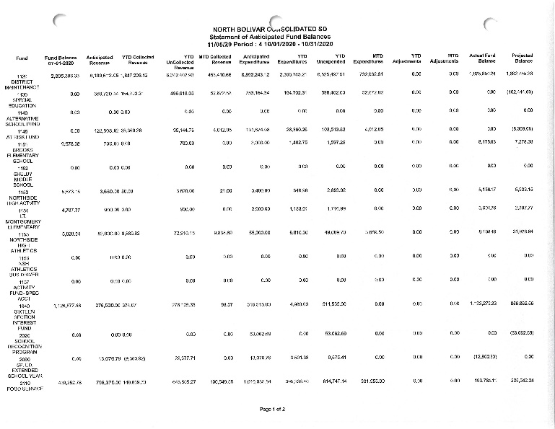
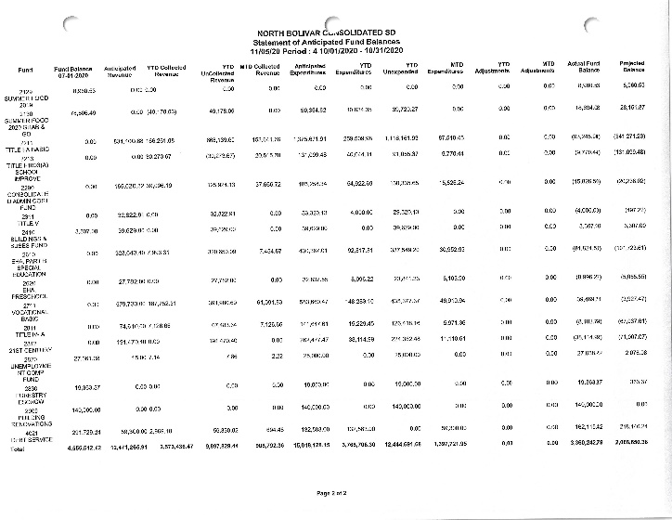
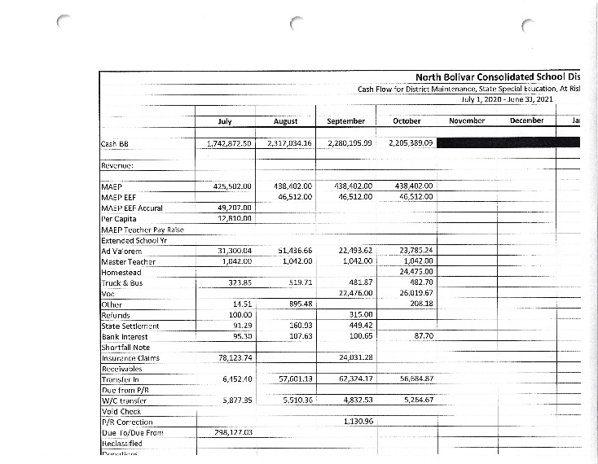

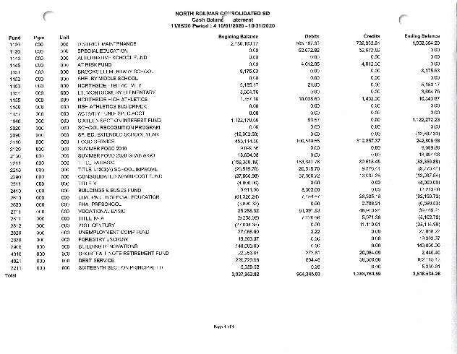

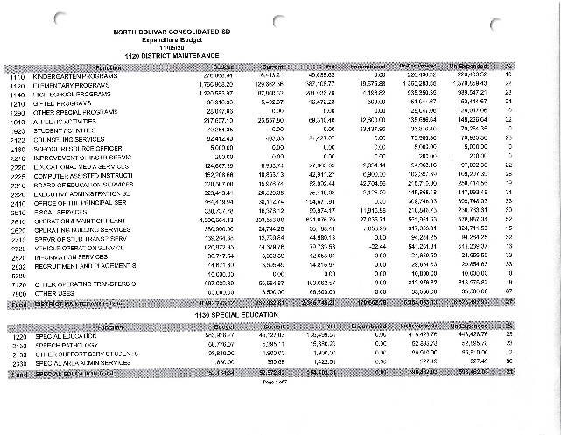

It was motioned by Mr. Tyrone Miller and seconded by Mrs. Jacquelyn Allen to approve all items under the Financial Report. Mr. Tyrone Miller, Mrs. Jacquelyn Allen, Mrs. LaShonda Walker, and Chairman Jefferick Butler voted aye. Mr. William Lucas voted against the motion. PASSED

- ADJOURNMENT
After no further actions or discussions, it was moved by Mr. Tyrone Miller and seconded by Mrs. Jacquelyn Allen to adjourn. Chairman Jefferick Butler, Mr. Tyrone Miller, Mrs. Jacquelyn Allen, Mr. William Lucas, and Mrs. LaShonda Walker all voted aye. There were no nays. PASSED
Board meeting adjourned at 6:22 p.m.
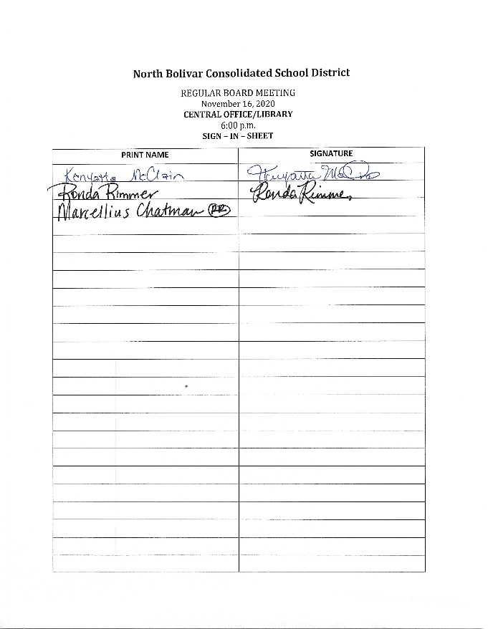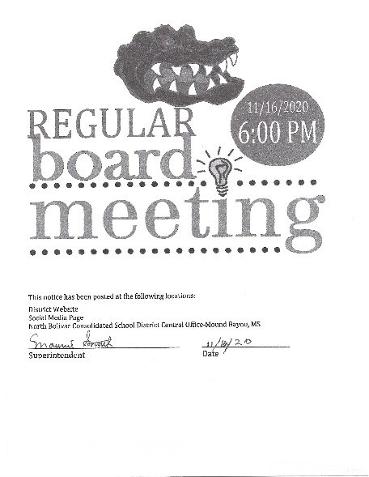

Attest: Approved:

________________________________ ________________________________
Secretary Board President

